QI-DISABILITY
FACT SHEET

WHAT IS QI-DISABILITY?
Quality of life refers to a person’s satisfaction with a composite of their life experiences.

The Quality of Life Inventory-Disability, QI-Disability, was developed to specifically assess the quality of life of children and adolescents with intellectual disability (aged 3-18). The instrument was designed by a team of Australian researchers in direct collaboration with the families and carers of individuals across the spectrum of intellectual disability.

Initial qualitative analyses for QI-Disability were conducted for children with Down syndrome, Rett syndrome (a severe genetic neurodevelopmental disorder mainly affecting females), and children with cerebral palsy or autism spectrum disorder who also have an intellectual disability. Since its development, studies exploring other diagnoses have utilised QI-Disability, including Prader-Willi syndrome (a rare genetic disorder affecting chromosome 15), CDKL5 Deficiency Disorder (a rare X-linked genetic disorder), and other Developmental Encephalopathy and Developmental Epileptic Encephalopathy conditions. Using QI-Disability for a range of conditions will allow for more comprehensive insight into service utility and intervention targeting the complex needs of this population, with the goal of the child’s quality of life as the target.

QI-Disability is being used as a monitoring tool in clinic settings and in observational research studies. It is being used as an outcome measure in clinical trials.

WHAT DOMAINS OF QUALITY OF LIFE DOES QI-DISABILITY MEASURE?

Physical Health
Social Interaction
Positive Emotions
Negative Emotions
Leisure and the Outdoors
Independence

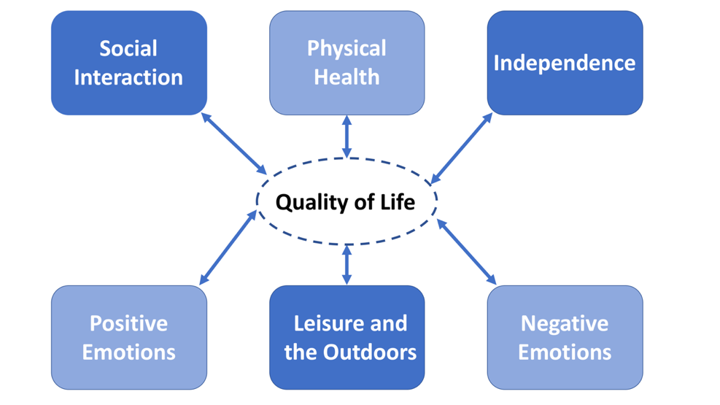
OUR DEVELOPMENT MODEL
QI-Disability was developed to address the need for a measure of quality of life constructed specifically for children and adolescents with intellectual disability. The instrument resulted from thematic analyses of 77 primary caregiver interviews, which were conducted to identify the quality of life domains and elements relevant to this population.

The figure below provides a summary of the goals and methodology of each phase of development of QI-Disability.

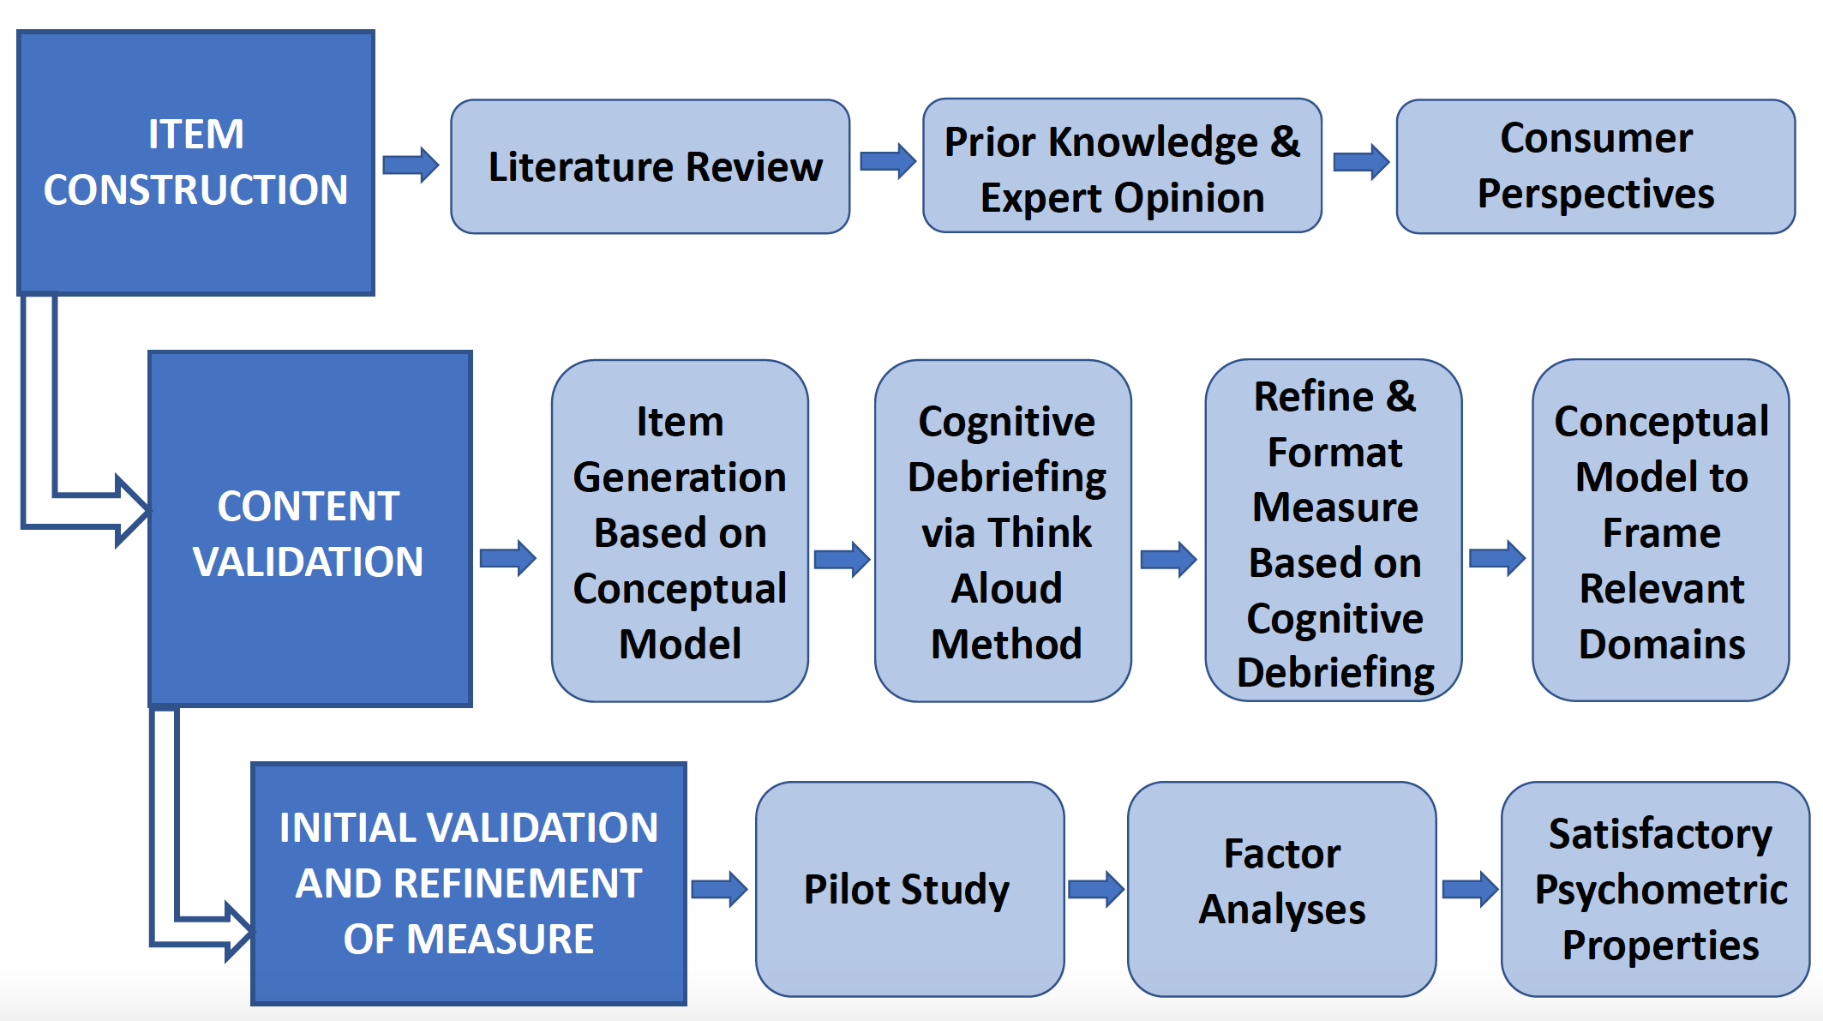

OUR QUESTIONNAIRE
QI-Disability measures children’s and adolescents’ health and wellbeing across 6 domains. The instrument was developed as a parent-report measure relevant to school-aged children (5-18 years) across the spectrum of intellectual disability severity.

Administration
QI-Disability can be completed by primary caregivers at home, school, clinics or in other contexts. It can also be administered by telephone, in-person interview, using an online platform, or as a paper questionnaire.

When QI-Disability is used, the following guidelines are recommended:
- All 32 items comprising QI-Disability should be given to the primary caregiver
- All items should be displayed in the same order as written
- All items should retain their exact wording as written
- Likert rating scales should retain the exact wording and order as written

Translations
QI-Disability has been translated into other languages, including Spanish (US), Spanish (Spain), French, Italian, German and Danish.

For more information or if you are interested in performing a new translation of QI-Disability, please contact:
A/Prof Jenny Downs | Principal Research Fellow
Phone: +61 8 6319 1763
Email: Jenny.Downs@telethonkids.org.au

Funding and Support
The development of QI-Disability was funded by the National Health and Medical Research Council (NHMRC). This series of studies commenced in 2014 and collaborators included the Telethon Kids Institute Perth, Royal Children’s Hospital Melbourne, and the Murdoch Children’s Research Institute.

We would like to acknowledge the following organisations for their support throughout the development of QI-Disability:

- National Health and Medical Research Council (NHMRC)
- Telethon Kids Institute
- University of Western Australia
- Murdoch Children’s Research Institute
- Royal Children’s Hospital Melbourne
- University of Melbourne

When publishing research study results using QI-Disability, please cite the following:

Downs, J., Jacoby, P., Leonard, H., Epstein, A., Murphy, N., Davis, E., Reddihough, D., Whitehouse, A., & Williams, K. 2018. Psychometric properties of the Quality of Life Inventory-Disability (QI-Disability) measure. Quality of Life Research, 28, 783-94.

CONTACT US
For requests please contact:
A/Prof Jenny Downs | Principal Research Fellow
Phone: +61 8 6319 1763
Email: Jenny.Downs@telethonkids.org.au

Postal address:
Attn: Dr Jenny Downs
Office of QI-Disability
Telethon Kids Institute
Perth Children’s Hospital
PO Box 855, West Perth, Western Australia, 6872
AUSTRALIA

Additional information about our research available at:
Telethon Kids Institute: https://telethonkids.org.au
The Child Disability Facebook Page: https://www.facebook.com/ChildDisabilityTelethonKids
University of Western Australia: https://www.uwa.edu.au
Murdoch Children’s Research Institute: https://www.mcri.edu.au
Royal Children's Hospital Melbourne: https://www.rch.org.au/
University of Melbourne: https://unimelb.edu.au

OUR PUBLICATIONS
Saldaris JM, Jacoby P, Leonard H, Benke TA, Demarest S, Marsh ED, Downs J. Psychometric properties of QI-Disability in CDKL5 Deficiency Disorder: Establishing readiness for clinical trials. Epilepsy & behavior : E&B 2023; 139: 109069.

Leonard H, Gold W, Samaco R, Sahin M, Benke T, Downs J. Improving clinical trial readiness to accelerate development of new therapeutics for Rett syndrome. Orphanet J Rare Dis 2022; 17: 108.

Leonard H, Whitehouse A, Jacoby P, Benke T, Demarest S, Saldaris J, Wong K, Reddihough D, Williams K, Downs J. Quality of life beyond diagnosis in intellectual disability - Latent profiling. Res Dev Disabil 2022; 129: 104322.

Downs J, Jacoby P, Saldaris J, Leonard H, Benke T, Marsh E, Demarest S. Negative impact of insomnia and daytime sleepiness on quality of life in individuals with the cyclin-dependent kinase-like 5 deficiency disorder. Journal of sleep research 2022: e13600.

Jacoby P, Williams K, Reddihough D, Leonard H, Whitehouse A, Downs J. Modelling quality of life in children with intellectual disability using regression trees. Dev Med Child Neurol 2022; 64: 1145-55.

Leonard H, Downs J, Benke TA, Swanson L, Olson H, Demarest S. CDKL5 deficiency disorder: clinical features, diagnosis, and management. The Lancet Neurology 2022; 21: 563-76.

Whitehouse A, Jacoby P, Reddihough D, Leonard H, Williams K, Downs J. The effect of functioning on Quality of Life Inventory-Disability measured quality of life in children with intellectual disability is not mediated or moderated by parental psychological distress. Quality of Life Research 2021; 30: 2875-85.

Reddihough D, Leonard H, Jacoby P, Kim R, Epstein A, Murphy N, Reid S, Whitehouse A, Williams K, Downs J. Comorbidities and quality of life in children with intellectual disability. Child Care Health Dev 2021; 47: 654-66.

Leonard H, Junaid M, Wong K, Demarest S, Downs J. Exploring quality of life in individuals with a severe developmental and epileptic encephalopathy, CDKL5 Deficiency Disorder. Epilepsy Research 2021; 169: 106521.

Williams K, Jacoby P, Whitehouse A, Kim R, Epstein A, Murphy N, Reid S, Leonard H, Reddihough D, Downs J. Functioning, participation and quality of life in children with intellectual disability: An observational study. Developmental Medicine and Child Neurology 2021; 63: 89-96.

Mendoza J, Downs J, Wong K, Leonard H. Determinants of quality of life in Rett syndrome: new findings on associations with genotype. J Med Genet 2021; 58: 637-44.

Strugnell A, Leonard H, Epstein A, Downs J. Using directed-content analysis to identify a framework for understanding quality of life in adults with Rett syndrome. Disability and rehabilitation 2020; 42: 3800-7.

Jacoby P, Epstein A, Kim R, Murphy N, Leonard H, Williams K, Reddihough D, Whitehouse A, Downs J. Reliability of the Quality of Life Inventory-Disability (QI-Disability) measure in children with intellectual disability, Journal of Developmental and Behavioral Pediatrics, 2020. May 12; 41:534–539.

Glasson EJ, Forbes D, Ravikumara R, Nagarajan L, Wilson A, Jacoby P, Wong K, Leonard H, Downs J. Gastrostomy and quality of life in children with intellectual disability: a qualitative study, Archives of Disease in Childhood. 2020 Oct;105(10):969-974.

Epstein A, Williams K, Reddihough D, Murphy N, Leonard H, Whitehouse A, Jacoby P, Downs J. Content validation of the Quality of Life Inventory - Disability (QI-Disability). Child: care, health and development. 2019 Jun 21;45(5):654-659.

Downs, J., Jacoby, P., Leonard, H., Epstein, A., Murphy, N., Davis, E., Reddihough, D., Whitehouse, A., & Williams, K. 2018. Psychometric properties of the Quality of Life Inventory-Disability (QI-Disability) measure. Quality of Life Research, 28, 783-94.

Tangarorang, J., Leonard, H., Epstein, A., & Downs, J. 2019. A framework for understanding quality of life domains in individuals with the CDKL5 Deficiency Disorder. American Journal of Medical Genetics Part A, 179(2), 2S49-56.

Epstein, A., Whitehouse, A., Williams, K., Murphy, N., Leonard, H., Davis, E., Reddihough, D., & Downs, J. 2019. Parent-observed thematic data on quality of life in children with autism spectrum disorder. Autism: International Journal of Research and Practice, 23(1), 71-80.

Davis, E., Reddihough, D., Murphy, N., Epstein, A., Reid, S.M., Whitehouse, A., Williams, K., Leonard, H., & Downs, J. 2017. Exploring quality of life of children with cerebral palsy and intellectual disability: What are the important domains of life? Child: Care, Health and Development, 43(6), 854-60.

Murphy, N., Epstein, A., Leonard, H., Davis, E., Reddihough, D. Whitehouse, A., Jacoby, P., Bourke, J., Williams, K. & Downs, J. 2017. Qualitative analysis of parental observations on quality of life in Australian children with Down syndrome. Journal of Developmental and Behavioral Pediatrics, 38(2), 161-8.

Epstein, A., Leonard, H., Davis, E., Williams, K., Reddihough, D., Murphy, N., Whitehouse, A., & Downs, J. 2016. Conceptualizing a quality of life framework for girls with Rett syndrome using qualitative methods. American Journal of Medical Genetics Part A, 170(3), 645-53.

